7.62: a) The skier’s kinetic energy at the bottom can be found from the potential energy at the top minus the work done by friction, or . Then 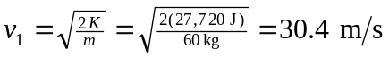.
b)
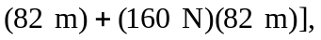 , or . Then,

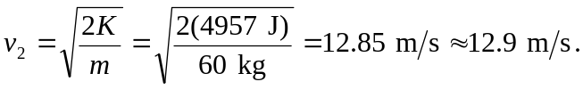

c) Use the Work-Energy Theorem to find the force. 